MOBILE APPLICATION

DEVELOPMENT

**Subject Code: (15IT324E)**

B.TECH III

Year / V Semester

**DEPARTMENT**

**OF COMPUTER SCIENCE ENGINEERING**

**FACULTY OF ENGINEERING & TECHNOLOGY**

**SRM INSTITUTE OF SCIENCE & TECHNOLOGY, Delhi NCR CAMPUS, MODINAGAR**

**SIKRI KALAN, DELHI**

**MEERUT ROAD, DIST.**

**–**

**GHAZIABAD**

,

**201204**

[www.srmimt.ne](http://www.srmimt.net/)

[t](http://www.srmimt.net/)

**Odd Semester (June**

**-**

**2019)**

**Name**

**:**

**1.**

**ANURAG DINGAR**

**( RA1711003030464 )**

SRM INSTITUTE OF SCIENCE & TECHNOLOGY, DELHI

-

NCR CAMPUS,

MODINAGAR.

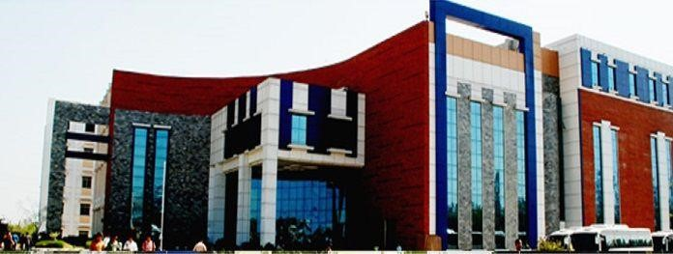

|  |
| --- |
| **BONA FIDE CERTIFICATE**    **Registration No:**   1. **RA1711003030464**     *Certified to be the bona fide record of work done by* ***ANURAG DINGAR*** *of 5th Semester 3rd Year B.TECH degree course in* ***SRM INSTITUTE OF SCIENCE ANDTECHNOLOGY, DELHI-NCR*** *for the department of* ***Computer Science & Engineering,*** *in* ***MOBILE APPICATION***  ***DEVELOPMENT*** *during the academic session of 2019-2020.*      **Faculty In charge Head of the department**                            SRM INSTITUTE OF SCIENCE & TECHNOLOGY, DELHI- NCR CAMPUS, MODINAGAR. |

CONTENTS

**ABSTRACT**

FILTER offers everything you want to edit pictures. A host of stylish effects, filters, grids and draw tools help you create an eye-catcher, even if you've never edited a photo before. With Photo Editor Pro, you can directly post your artworks to Instagram, Whatsapp, Facebook etc. Unlock your creativity, and edit pictures like a pro

FILTER is an android application made on android studio using java language . FILTER gives you quick new look to your memories making quick fixes and amazing effects.

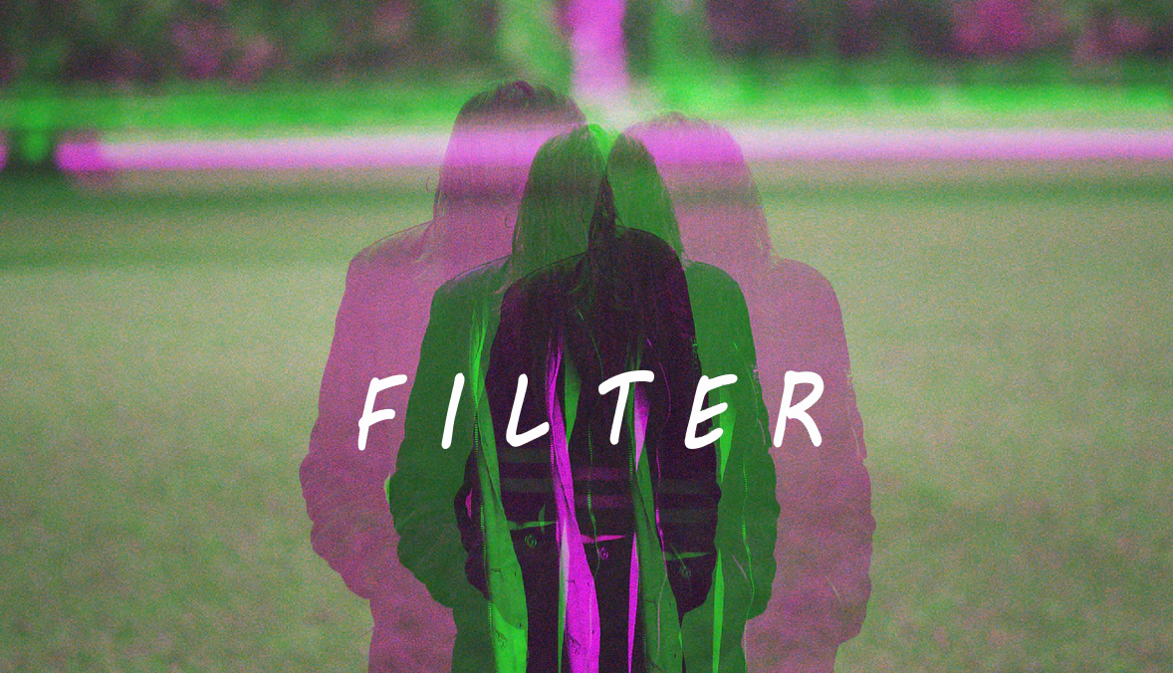

# ACKNOWLEDGEMENT

If words are considered as a symbol of approval then let the words play the heralding role expressing our gratitude. The satisfaction of successful completion of any task is incomplete without the mention of people whose cooperation made it possible.

We would like to show our gratitude towards **Ms. Ayushi Pandey** under whose mentorship this project was completed. We’ve learnt a lot of new things in the path of completing this project.

We would be obliged if you call us for any explanation or any query about the report as and when deemed necessary .

**INTRODUCTION**

Editing photos isn't lying. It's not cheating or telling people this place looks prettier than it is - it's simply enhancing the already existing elements of a photograph to help them stand out more and to make a photo more pleasing, balanced, and better quality. They're not adding new things or changing existing parts. They're just…adding some more cream onto a cake.

I was crashing at a family friends place the other night, took a photo of the view from her house. The next day, I proceeded to take another photo from roughly the same spot of the same view, as I thought it would be pretty interesting to see the differences between night and day.

That day we decided to make our FILTER android application which fills color in our pale and colorless life like Tirupati mess food .

There is a lot of debate on whether or not, a photo should be post processed/edited. Editing doesn't always mean using image photoshop to manipulate the entire image like putting something in image which wasn't there in the original scene. Some darkroom techniques can also be used. I am a hobby landscape photographer, and I edit my pictures too. But e Editing can also be used to enhance the image. Below are the reasons most of the photographers edit their pictures.  
  
**To bring them to reality:** There is no camera in this world which can capture the original scene as it is. Cameras have limitations capturing scenes with high dynamic range, challenging lighting situations etc. So the pictures captured by cameras look much more dull and uninteresting than the original scenery. So most of the professional as well as amateur photographers, including myself, use some techniques which help photos to look like the scene the way it was. The techniques like, exposure blending can be used for this purpose. Exposure blending helps getting even exposure throughout the image. Its not always editing, use of photographic filters (optical) can result in great images, whereas person not aware of these technical things/jargon might call it editing. Moreover, cameras don't capture colours and contrast range the way we see with out naked eye, so the same can be adjusted to a level closer to the reality.  
  
**It's a technique, not an edit:** There are several techniques that are used in the photography. These techniques can be used to capture the images in a surreal way. These techniques allow the scene to be captured in a surreal way that it creates a stunning image, representing finest of the art. Common people are not aware of these techniques, and hence photographs captured using these techniques are often called as "edited" or "photoshopped". One of such technique is using slow shutter speeds. This is widely used and very well known technique across the photographers. Slow shutter speeds lets you capture the motion in the scene rather than freezing it. Below are few of the photographs I captured using this technique:

Other of such kind of techniques can be panning, bokeh, DOF etc.  
  
**Photography is an art:** Not all the photos serves the purpose of showing the scene as it is. For example, when it comes everyday or documentary photography, the least editing/enhancements are required to keep the image closer to the reality, whereas when it comes to portrait photography, wedding photography, product photography or model photoshoots, the purpose usually is not to show the scene/person as it is, but to show it in a more beautified way so that it makes the originals appear more beautiful and catches viewer's eye. Image all the portrait/wedding/model/product photos appearing dull just like captured with a cellphone;  you see, nobody would pay attention to them. Frankly speaking, fine art photography has no rules set about photo editing or manipulation. Artist is free to use his imagination and skills to create a photograph that represent finest of the art.  
  
**Money Matters:** Nobody likes to hang a dull and uninteresting image on their wall. A little bit of enhancing might make a huge difference and sell the image which was once dull. There are very of the images that exist where were not enhanced/edited and sold to the world at a good price.

We bring you open source alternative to expensive apps like pixer ,pics art etc.

SYSTEM ANALYSIS

1. **SYSTEM ANALYSIS**

This app enables us to **EDIT AND APPLY FILTERS** on photos of yours with brightening colors and create new beautiful images you can share**.**

**System Specification:-**

***Hardware Specification:***

RAM: 512MB and above.

Memory: 3MB of free space

***Software Specification:***

Android Version: 4.0 (Ice Cream Sandwich) and above.

**Normal User:**

S/He can only use the app for applying filter on their images.

**Requirements:**

**Functional:**

Need to upload photo in application to use filters.

Apply filters and share photos.

**Non-Functional:**

* + - 1. ***Portability:***

The app is designed to work on most popular OS for smartphones, i.e. Android.

* + - 1. ***Re-Usability:***

The app’s code could be reused to add further changes and updates to the app.

SYSTEM DESIGN

**System:**

* + - * + A system is a basic complete functional computer including all the hardware and software required to make it functional.

* + - * + The system should be able to take input, process the data and produce data for storage and/or for output.

**System Design:**

This phase focuses on defining the modules and architecture of the system (Connecting Dots, in this case) which will help us making it accordingly the given information without any changes resulting in prevention of using more time and energy than required.

**Input Design:**

Input design is the part which tells us about the diff. methods to take input from the user as it is the most important information needed to produce the desired output.

Our app will have a single source of input which will be the screen of their phones.

**Output Design:**

Output design is that part which enables us to define diff. types of output methods which can be used to show the result of our processed data.

Our app will have a single source to output the content which will be their phone’s screen as our main objective is to display the winner of that game.

**Modules:**

The main goal of our app is to transmit data over long distances using Internet to help people stay connected one way or the other. The app has following modules:

* + - * + Developers
        + Normal User

Page

***Developer:***

The Developer can view and change the backend of the app to add new features and do other changes in it.

**Project Information:**

The Developers will be able to make any changes to the source code of the app which means s/he can:

➢ Make changes according to the provided details either based on the feedback or from the higher authorities

**Report:**

This is to notify the Project manager on the current position of the duties assigned to him/her.

**Self:**

It will be including all of his/her personal information.

***Normal User:***

The Normal User can use the app playing with another person.

**Self:** The user can use the app for playing.

The users are also welcome to give suggestions and/or any tell us about any bugs which they may find via E-mail.

DATA FLOW DIAGRAM

1. **Data Flow Diagram:**

A Data Flow Diagram (or **DFD** for short) is a diagram which shows the flow of data or information for any process or system. In DFDs we use defined symbols like circles, rectangles, etc. with a little text in them to depict how the data is going to move in our system. DFDs can virtually “say” many things which are mostly hard to explain and can work for both technical (Developer) and non-technical (CEO) audiences as well.

DFDs can be as simple as they can be hard for more complex systems.

They always start from Level 0 and go further ahead.

0 Level DFD is also known as “**Context Flow Diagram (CFD)**”. It basically shows the inter- relationship between diff. kinds of users.

**5.1) Symbols:**

***5.1.1) External Entity:***

This symbol is used to define all kinds or external input and user which are responsible for any kind of Input in the system.

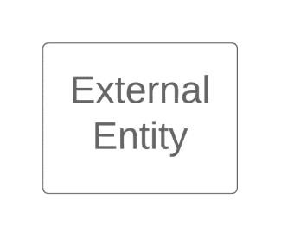

***5.1.2) Process:***

This symbol is used to define diff. kinds of processes taking place in the system

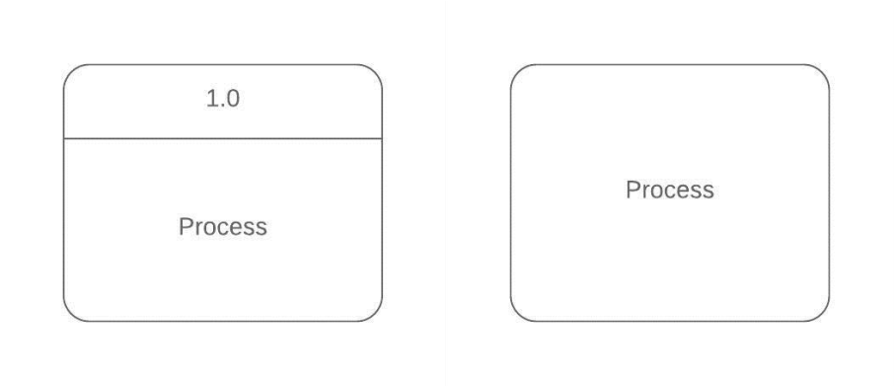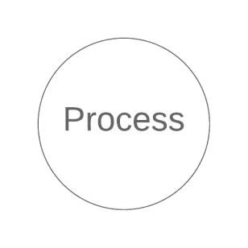

.

***5.1.3) Data Store:***

Page

This one particular symbol is used to tell about the data or data module which is going to be implemented upon.

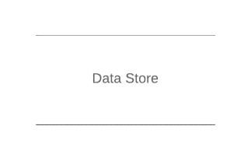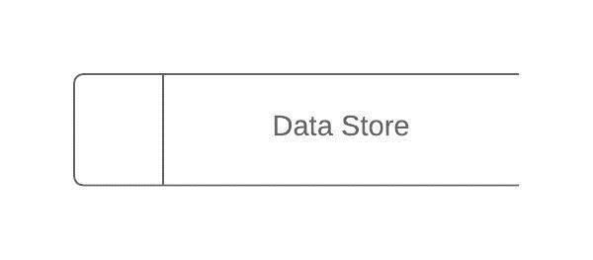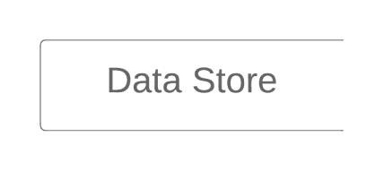

***5.1.4) Data Flow:***

This symbol is used to tell about the direction of flow of data or information in the system.

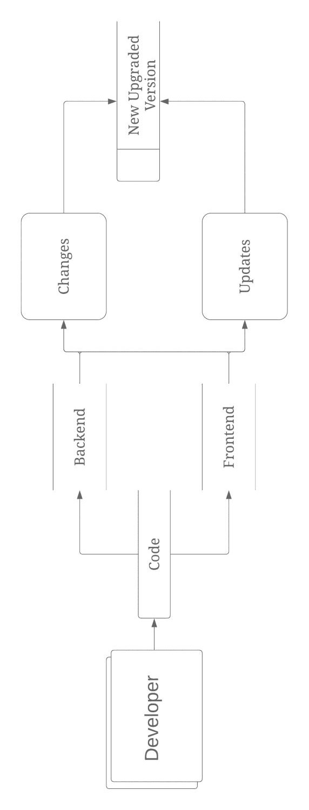

Level 1 DFD (Developer)

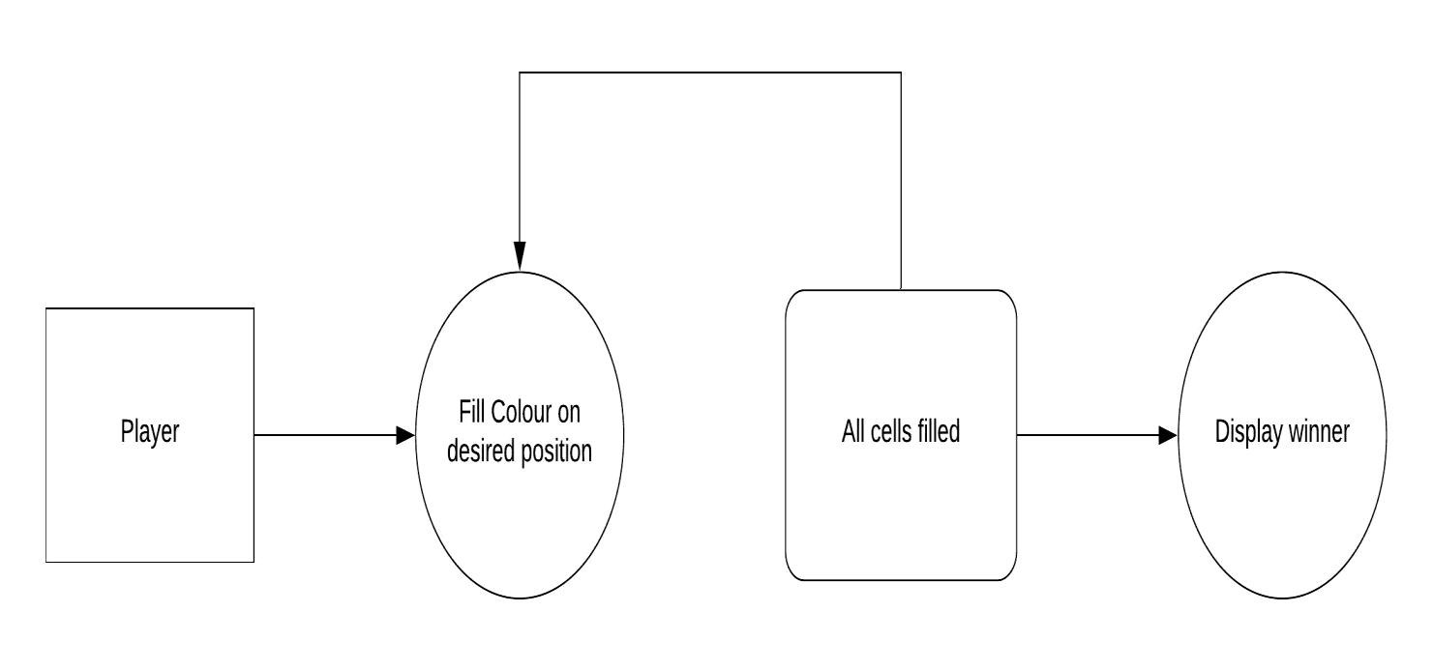

# VARIOUS ACTIVITIES IN THE “FILTER”ANDROID APPLICATION

FIRST ACTIVITY : Landing page of Application.

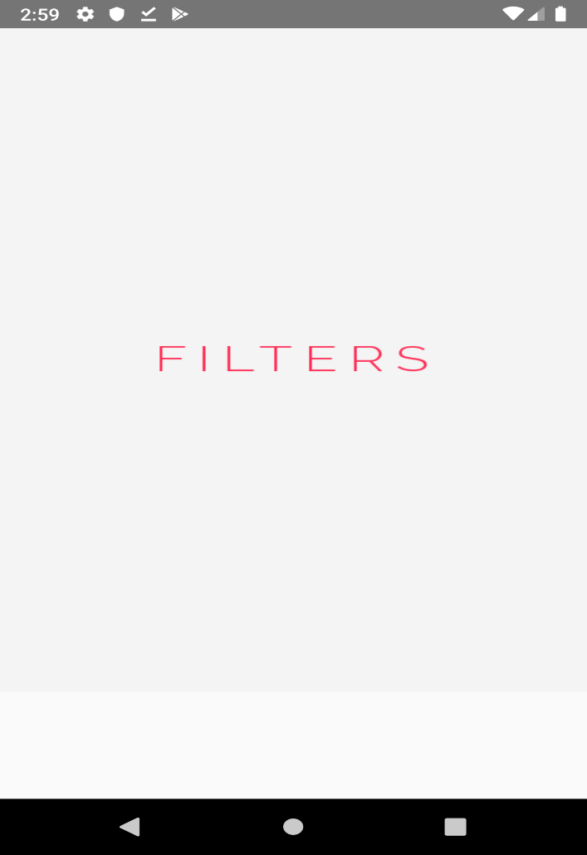

SECOND ACTIVITY:

BROWSE AND SELECT IMAGE TO EDIT.

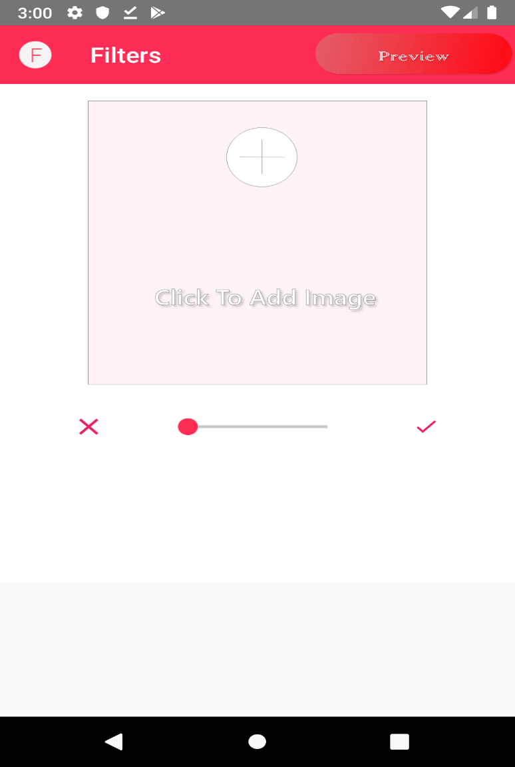

THIRD ACTIVITY:

BROWSE YOUR IMAGE FROM FILE EXPLORER.

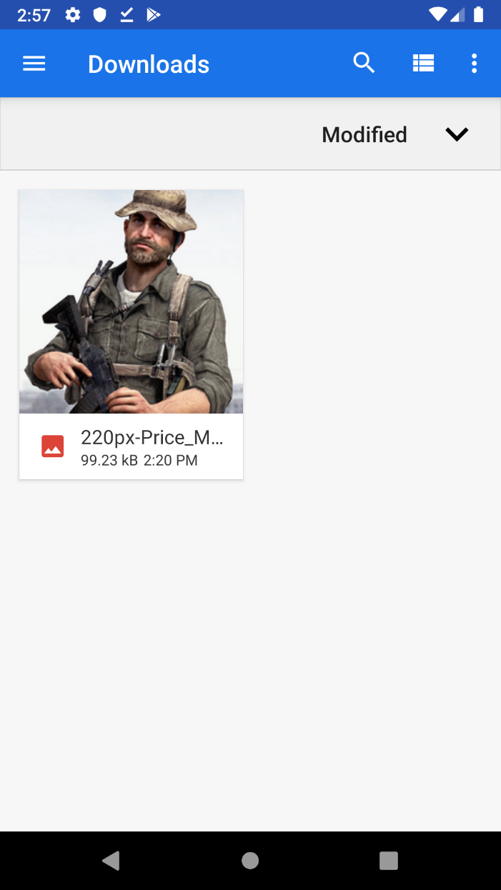

FOURTH ACTIVITY:

APPLY FILTERS

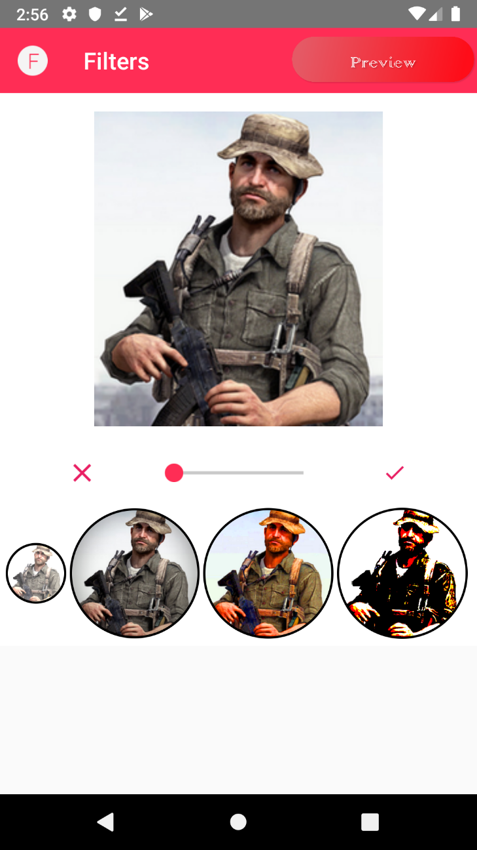

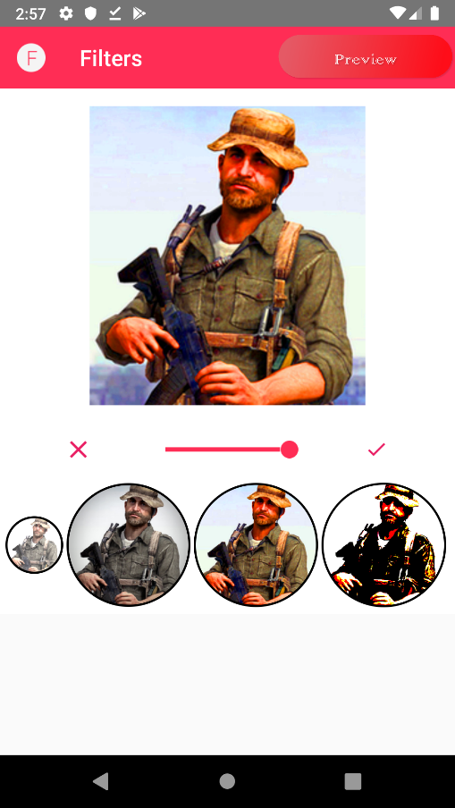

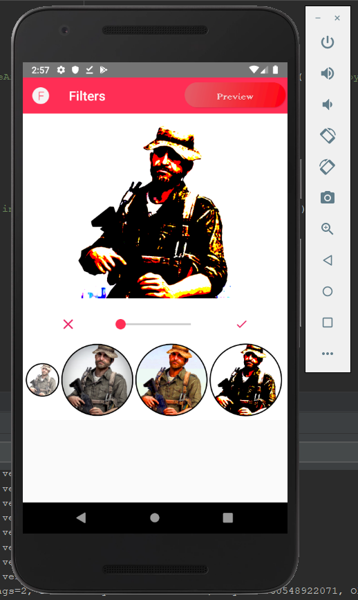

FIFTH FILTER:

FILTER APPLIED

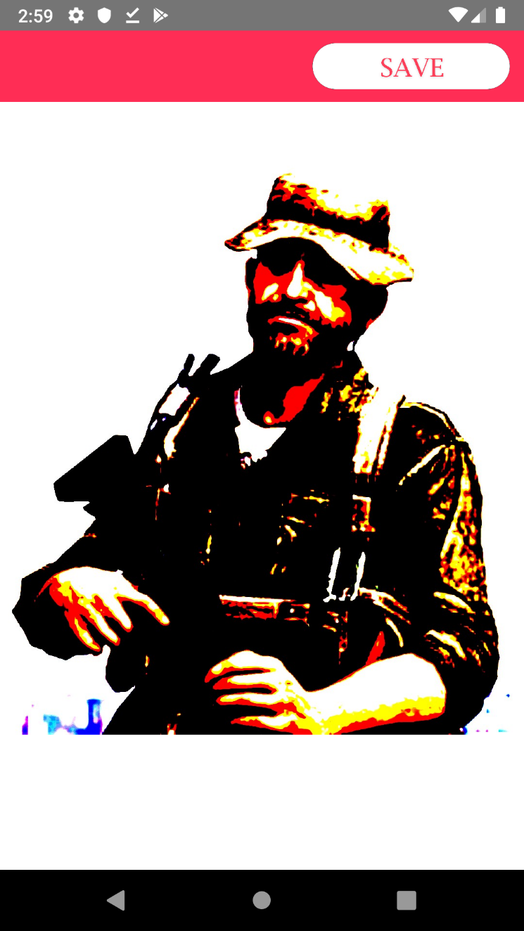

SIXTH ACTIVITY:

FILTER APPLIED AND NEW IMAGE SAVED

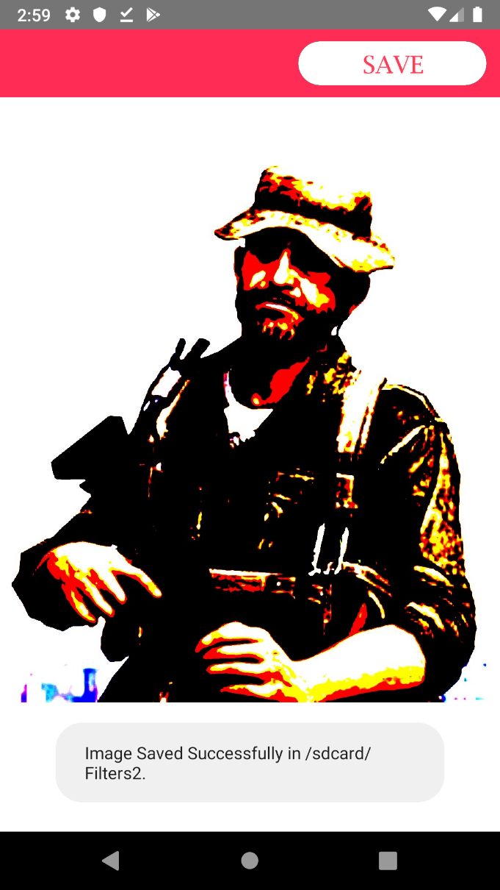

TECHNOLOGY STACK:

PICASSO - A library for applying various filters used in app.

ANDROID STUDIO - IDE used while developing the application.

**Maintenance**

There are number of things which are considered when putting a system in production. It is also very important to put all these in the project plan.

Once the project has been built it should be thoroughly tested before putting it into production.

**Need of Maintenance:**

Maintenance is the modification of the product after delivery to correct details. A common perspective towards maintenance is that it only involves fixing defects. Maintenance is needed to be done:

* + - * To correct problems
      * Improve Design
      * Implement Enhancements
      * Make it more flexible towards different technologies

**Types of Maintenance:**

In Software Maintenance there are basically 4 types of maintenance:

***Corrective:***

This type of maintenance is essential to rectify bugs when system is in use or for performance enhancement.

***Adaptive:***

This type of maintenance includes updating or modifying the product to run on new platforms or hardware.

***Perfective:***

This type of maintenance includes updating or modifying according to user feedback.

***Preventive:***

This type of maintenance includes updating or modifying to prevent future issues which may not do something right now but can produce issues in the future.

**Problem Encountered:**

When the code of our project finally completed we were only facing 1 problem which was of the gradle not being to sync properly.

**CONCLUSION**

**Conclusion:**

The app hasn’t been developed and is still in its development phase because of some compatibility and gradle issues. The current app is flexible and can be changed easily whenever deemed necessary using the functionalities of Android. It is developed in a simple manner, hence reducing the developer’s workload.